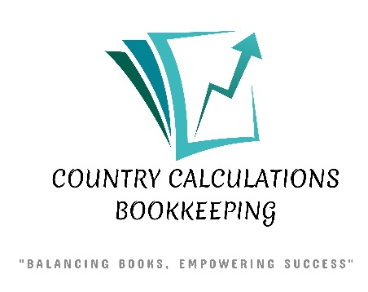
BOOKKEEPING PACKAGES | ENTRY | ESSENTIAL | STANDARD | PREMIUM
MONTHLY PRICING FROM | $160 | $300 | $400 | $550
Monthly Transactions | Up to 20 | Up to 50 | Up to 150 | Up to 250
Bank/Credit Card Reconciliation Accounts | 2 | Up to 3 | Up to 5 | Up to 8
Bookkeeping Frequency | Monthly | Monthly | Monthly | Weekly
Payroll |  |  | Up to 5 Employees | Up to 10 Employees
Payroll Source Deductions Filing |  |  | Yes | Yes
Year End T4, T4A and T5018 Remittance |  |  | Yes | Yes
ROE Preparation and Filing |  |  | Yes | Yes
GST/HST Filing |  | Annual or Quarterly | Annual or Quarterly | Annual, Quarterly or Monthly
WSIB Filing | Yes | Yes | Yes | Yes
Online Access | Yes | Yes | Yes | Yes
1 hour of support per month by email, phone, text or in - person is included in all packages.
QuickBooks Online and QuickBooks Payroll are extra, and price depends on the subscription you choose or require.
Prices do not include HST.
Need something specific? My hourly rate is $30 + HST.

