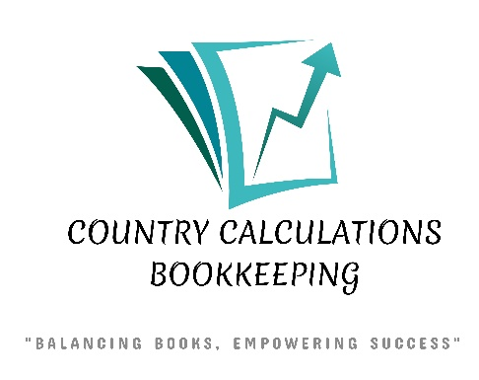

TAX SERVICES | PRICING STARTING FROM
INDIVIDUAL T1 | $80.00
SENIOR INDIVIDUAL T1 (60+) | $75.00
COUPLES T1 | $150.00
SENIOR COUPLES T1 (60+) | $140.00
RENTAL INCOME T776 | $150.00
SELF EMPLOYED T2125 | $200.00
Prices include a PDF file of your return. Full paper copies are $5.00 extra. (summary only is free)
Starting price includes as an example: T4, T4RSP, Medical Expenses & Charitable Donations.
Extra slips will be billed at $3.00 each.
Self Employed price is with Financial Statement provided by client.
Call 519-334-3760 or email countrycalculationsbookkeeping@outlook.com for more information.

